**Hotel Booking Cancellations: A Data-Driven Exploratory Analysis**

**Business Problem:**

In recent years, both City Hotel and Resort have experienced high cancellation rates. As a result, they are facing several challenges, including reduced revenue and sub-optimal room occupancy. Consequently, reducing cancellation rates has become a primary goal for both hotels to enhance their efficiency in generating revenue. Our objective is to provide comprehensive business recommendations to tackle this issue effectively.

This report focuses on analyzing hotel bookings and yearly trends, among other relevant topics, to identify the main factors contributing to the high cancellation rates. By understanding these factors, we aim to develop strategies to improve overall business performance and reduce cancellations.

**Assumptions:**

* **Data Reliability:** No unusual occurrences between 2015 and 2017 significantly impact the data used for this analysis, ensuring its reliability.
* **Data Relevance:** The information remains current and can be effectively used to analyze and plan future strategies for the hotel.
* **Current Practices:** The hotels are not currently implementing any of the suggested solutions presented in this report.
* **Impact of Cancellations:** Booking cancellations are the biggest factor affecting the hotel's ability to generate income efficiently.
* **Vacancy Issues:** Cancellations lead to rooms remaining vacant for the duration they were initially booked, resulting in lost revenue opportunities.

**Research Questions:**

* What are the variables that affect hotel reservations cancellations?
* How can we make hotel reservations cancellation better?
* How will hotels be assisted in making pricing and promotional decisions?

**Hypothesis:**

* More cancellations occur when prices are higher
* When there is a longer waiting list, customers tend to cancel more frequently.
* The majority of clients are coming from offline travel agents to make their reservations

**Analysis & Findings:**

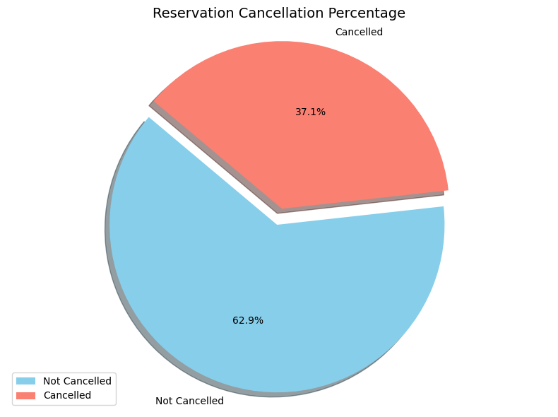

There are still 37% of clients cancelled their reservations, which continues to impact hotel earnings and highlights the need for better cancellation control.

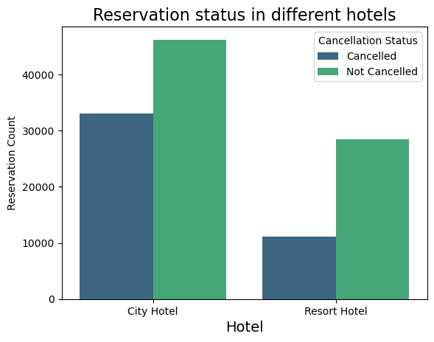

In comparison to resort hotels, city hotels have more bookings. It’s possible that resort hotels are more expensive than those in cities.

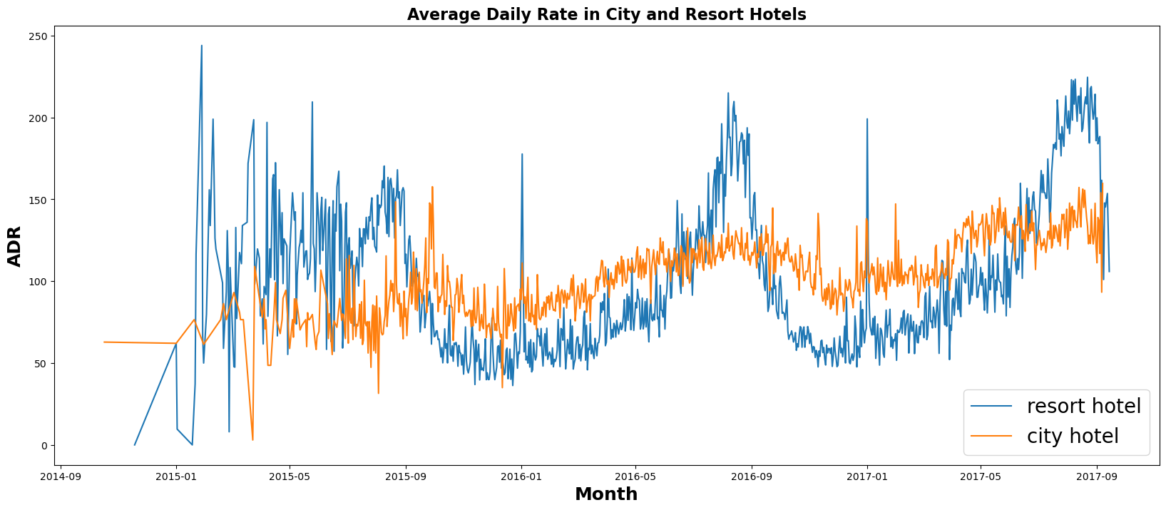

The line graph compares the average daily rates between city hotels and resort hotels over a period of time. The data reveals that while city hotel rates generally maintain a lower average, there are notable instances where resort hotel rates surpass those of city hotels. Particularly during weekends and holidays, resort hotel rates exhibit significant peaks, indicating increased demand and pricing. This fluctuation underscores the dynamic nature of hotel pricing influenced by seasonal trends and consumer preferences.

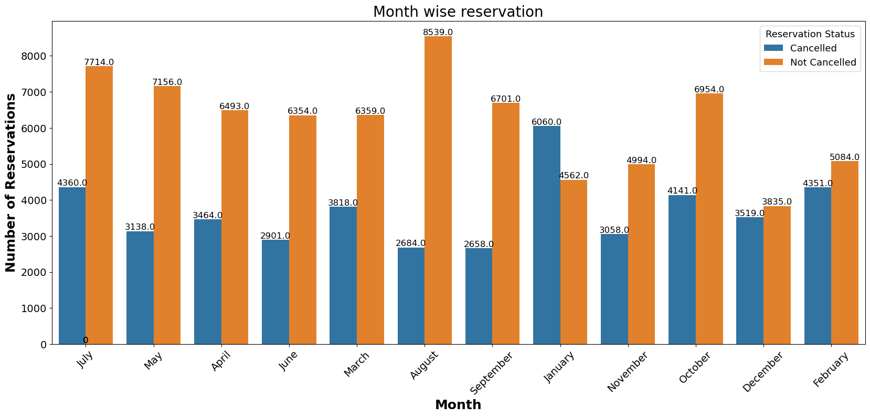

We have developed the grouped bar graph to analyze months with highest and lowest reservations levels according to reservation status.August records the highest number of confirmed (not cancelled) reservations, while January has the highest number of cancellations. Overall, reservation activity peaks in the summer months, indicating strong seasonal trends.

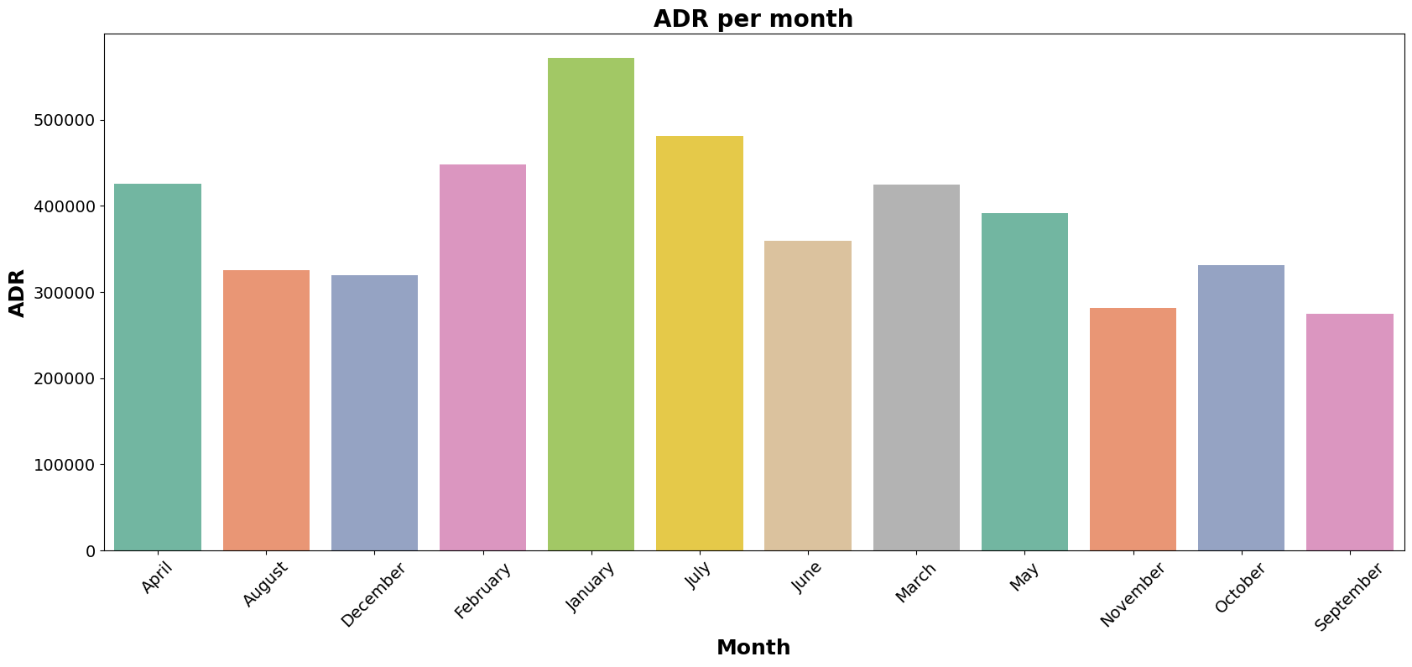

This bar graph clearly shows that cancellations tend to occur more frequently when hotel prices are higher and less frequently when prices are lower. Specifically, at the beginning of the year when hotel prices are highest, we observe a peak in cancellations. In contrast, from August onwards when prices are lower, cancellations decrease. This pattern suggests a direct relationship between accommodation costs and cancellation rates. Understanding this correlation is essential for managing reservation dynamics and pricing strategies effectively in the hospitality industry.

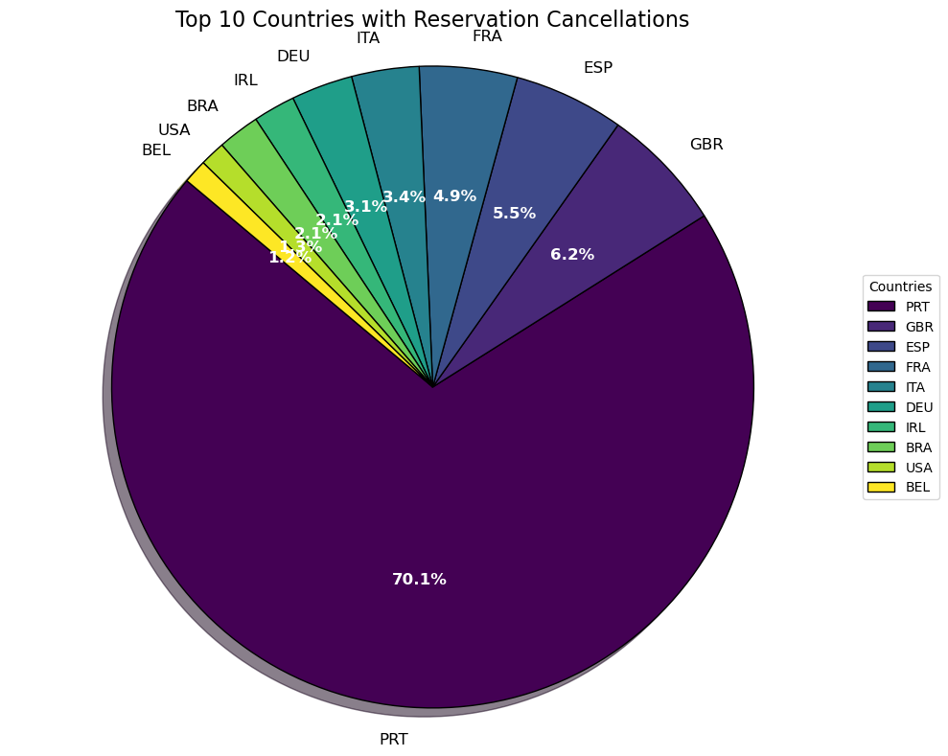

Portugal (PRT) shows the highest proportion of reservation cancellations, contributing to 70.1% of the total among the top 10 countries.

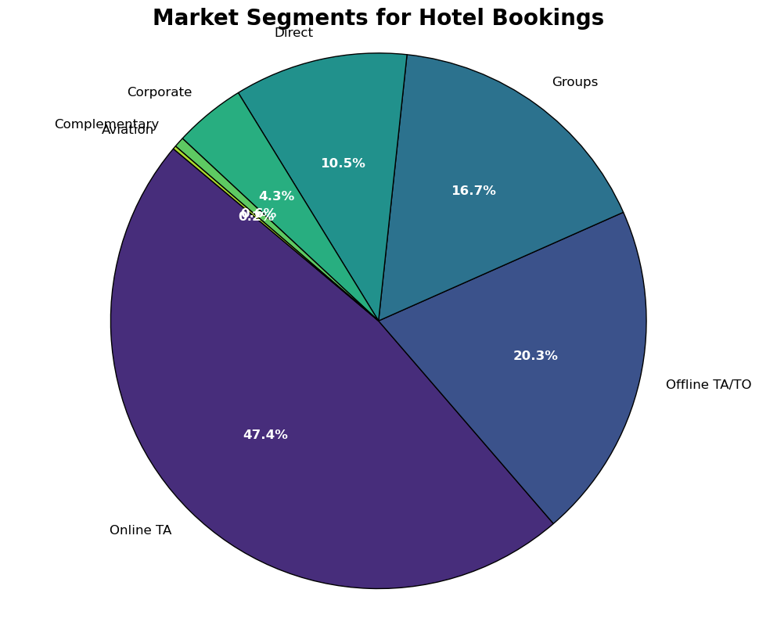

The chart shows that most hotel bookings—about 47.4%—come from online travel agencies. Offline travel agents account for 20.3% of bookings, while only 10.5% of guests book directly with the hotel. Group bookings also form a significant segment at 16.7%, highlighting the dominance of third-party channels in hotel reservations.

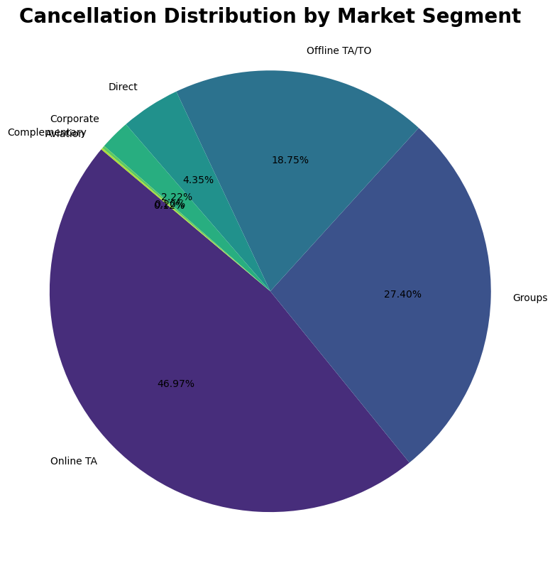

The chart highlights that nearly 47% of cancellations come from online travel agencies, followed by group bookings at 27.4% and offline agents at 18.75%. This shows that bookings made through third-party and group channels have a higher likelihood of cancellation, which is crucial for shaping cancellation policies and revenue strategies.

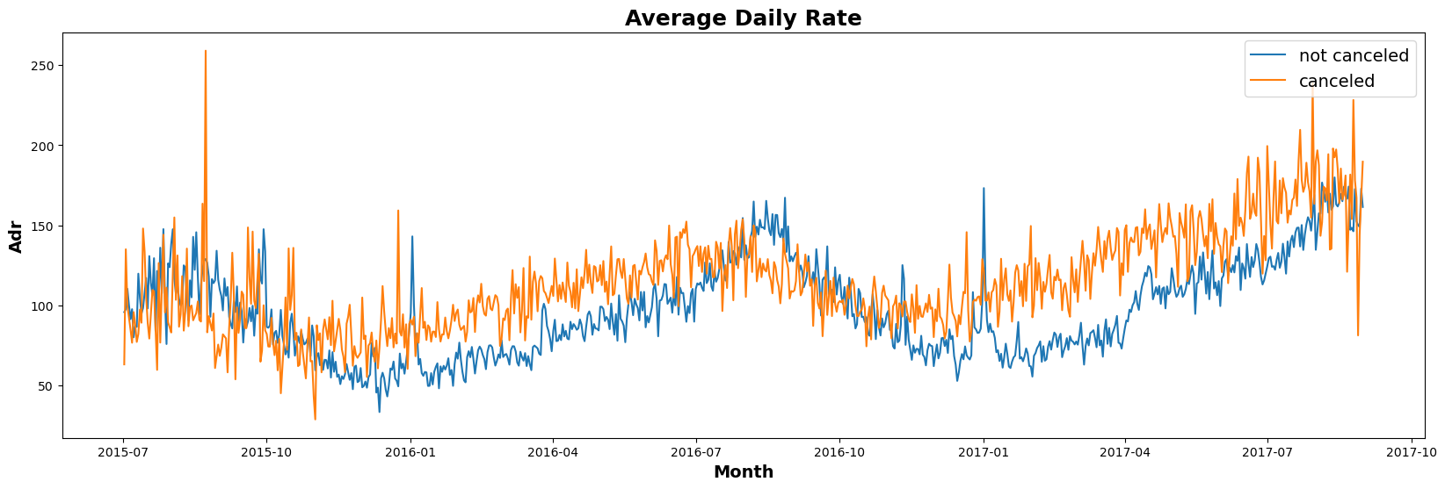

As seen in the graph, reservations are more likely to be canceled when the average daily rate is higher. This supports the analysis that higher prices lead to increased cancellations.

**Suggestions:**

* **Cancellation Rates and Pricing Strategies**

**Trend:** Cancellation rates tend to rise as prices increase.

**Strategy:** To prevent cancellations, hotels can implement pricing strategies, such as lowering rates for specific locations and offering discounts to consumers.

* **Resort Hotels vs. City Hotels**

**Trend:** The cancellation ratio is higher for resort hotels compared to city hotels.

**Strategy:** Resorts could address this by offering reasonable discounts on room prices during weekends or holidays.

* **January Campaigns**

**Trend:** January sees a high number of cancellations.

**Strategy:** Hotels can launch marketing campaigns with attractive offers in January to boost revenue and reduce cancellations.

* **Quality Improvement**

**Focus:** Hotels should prioritize enhancing quality and services, especially in areas critical for customer satisfaction.